SAFEGUARDING NEWS


SAFEGUARDING MATTERS NEWSLETTER – MARCH 2018
The Independent Inquiry into Child Sexual Abuse (IICSA)
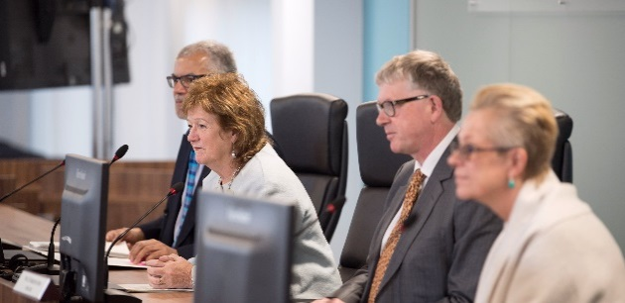
IICSA will be holding three hearings as part of its Anglican Church’ investigation involving the Church of England. The first will start on Monday March 5 and will be a case study into the Diocese of Chichester. It will last for three weeks. It will be followed by a one-week hearing in July (23-27) into the Bishop Peter Ball case and finally there will be an overall hearing into the Church and safeguarding in 2019.

Please read the Parish Q & A’s on IICSA which is available here


‘We Asked for Bread but You Gave Us Stones’

This is a powerful and moving booklet, in which victims of abuse,
address the Church in their own words collated with an
introduction by Andrew Graystone who is a journalist and
communications adviser.

‘‘Imagine yourself as a victim and think how you would want to be treated.’’

The booklet can be accessed here ….

Safeguarding Presentations from General Synod February 2018

The Bishop of Bath and Wells, Peter Hancock, the Church of England’s lead safeguarding bishop addressed February’s Synod on national developments and the Church’s preparation for the Independent Inquiry into Child Sexual Abuse, IICSA. The Bishop of Gloucester, Rachel Treweek, the Bishop of Chichester, Martin Warner and Sir Roger Singleton, a member of the Church’s National Safeguarding Panel, also addressed Synod. Read the presentations here

Training
In line with national policy expectations there is a requirement for all paid and voluntary workers to undertake safeguarding training. This includes both online and face to face diocesan training. Online training is available on the diocesan webpage and must be completed prior to taking on any role.
C0 Basic Awareness and C1 Foundation are both now available on line. Face to face diocesan safeguarding training should be booked onto as soon as possible for those who are new in post or have not undertaken training provided by the diocese during the last three years.
S3 - Domestic Abuse
This module examines issues relating to domestic abuse, especially for vulnerable groups and children in the context of adult abuse, and how the Church can respond well to this.
Who must attend? Anyone holding the Bishop’s Licence or Permission to Officiate, Spiritual Directors, Pastoral Visitors, Leaders of children/adult’s activities, Diocesan/Parish/Cathedral safeguarding officers, Senior staff teams, Churchwardens, Youth Workers
The following dates are currently available for this training.
Thursday 10th May 2018 | 10am - 12 noon | Diocesan Offices, Clayton House | Clayton
Thursday 21st June 2018 | 6.30pm - 8.30pm | Diocesan Offices, Clayton House | Clayton  Book a place here
Surgeries for Parish Safeguarding Officers
Safeguarding in the Diocese is only possible due to the individuals within our 235 parishes who volunteer their time and skills to ensure that those most at risk continue to be kept safe. 95% of our Churches now have parish safeguarding officers in post. Our part, as the Diocesan Safeguarding Team, is small relative to those who are the main point of contact for safeguarding in their parish. It is because of this that we will be starting to offer safeguarding surgeries for parish safeguarding officers. The first one is being held on Thursday 3rd of May 10-12.30 at Clayton House. There is an opportunity to meet with Gaynor Philpott, the parish safeguarding officer, who is your representative on the Diocesan Safeguarding Advisory Panel and raise any issues that you would like to be discussed at the panel. There will also be the opportunity to network, meet with the safeguarding team and ask any questions you may have. Places are limited and booking is via Eventbrite here.
GDPR is coming – are you ready?
You may have heard the law regarding the protection of personal data is changing.
On May 25, 2018, the General Data Protection Regulation (GDPR) will replace the Data Protection Act 1998.
Parishes, in common with the Diocesan Offices, need to know what things they should keep doing and what things they should do differently to comply with the new law.
Staff at the Diocesan Offices and in the national church are working hard to support parishes. How do you find out more?

- For general advice on preparing for GDPR search ‘GDPR’ on the Diocesan website www.blackburn.anglican.org and you will be taken to a dedicated page with helpful articles and links to other websites and online resources.
- Visit the Parish Resources website (www.parishresources.org.uk) which contains a wealth of advice for parishes on GDPR (including full Q and A’s; checklists and audit forms).
- Additional information will also be available via our regular communications channels such as The See magazine; the Communications Update email and on the Diocesan website

Dealing with concerns or something you feel unsure about
If you are worried about a child or adult who is being harmed or at risk of being harmed then please contact the Diocesan Safeguarding Officer, Sharon Hassall on 01204 503088 or email at Sharon.hassall@blackburn.anglican.org CCPAS (Churches Child Protection Advisor Service) may be contacted out of hours on 0303 003 1111.

