THE ARCHDEACONRY OF BLACKBURN

DEANERIES OF Accrington, Blackburn with Darwen, Chorley and Leyland

(NB This notice should be displayed prominently on the church notice board on the next Sunday after receiving it)

To the Churchwardens,

I hereby give notice that you are requested to attend the Primary Visitation for the Admission of Churchwardens to be held at Hoghton Holy Trinity, Blackburn Old Road, PR5 0SJ at 7:30pm on Monday 8th June 2026.

It is essential that those who have been elected to serve as Churchwardens for the year 2026-2027 should be present on this occasion to be sworn in by the Bishop of Blackburn, and having first completed the Declaration provided upon entry to the building.

A form of nomination for Churchwardens, with details of how nominations should be made, together with details of those who are excluded from election, are provided on the Diocesan website, www.blackburn.anglican.org/Archdeacons pages. Please print this notice as appropriate.

If you are unable to attend this visitation, you are required to attend one of the three other Services to be held across the Diocese. Please refer to the website for alternative dates and venues and advise kelly.quinn@blackburn.anglican.org.

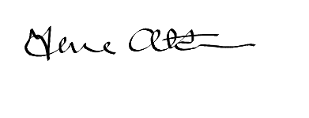

Archdeacon of Blackburn

Ven Jane Atkinson

March 2026

