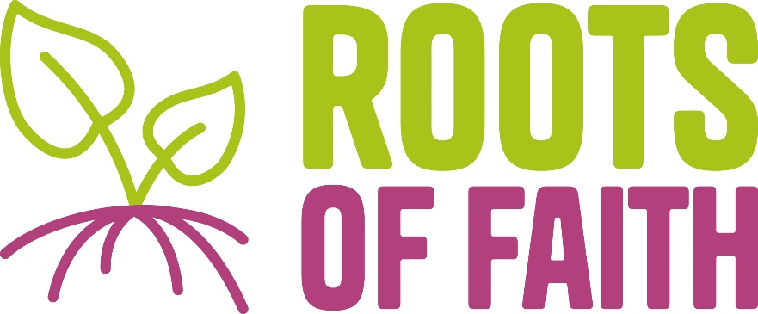

Remembering: the People of God and the Old Testament

Date & Time | Session Plan
Tuesday 21st Feb  7:30pm-9:30pm  The Acregate Centre, Preston | Entering the Library  - The structure of the Old Testament and understanding how the books fit together  - Tools for reading the Old Testament
Tuesday 28th Feb  7:30-9:30pm  Zoom | The Family Saga- Genesis  - Creation Accounts in Genesis  - Abraham’s Journey with God.
Tuesday 7th March  7:30pm- 9:30pm  Zoom | Becoming a Nation- Exodus to Deuteronomy  - Exodus- Leaving Egypt  - How do we read the Law?
Saturday 19th March  10am - 4pm  Whalley Abbey | God and his people speaking- History, Prophets and Wisdom.  - Judges and Kings- How did God lead His people?  - How did God speak through His prophets and how do they speak to us?  - The Psalms and how they help us pray today.

