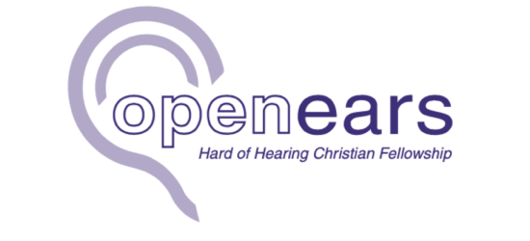

FOR IMMEDIATE RELEASE

Open Ears Launches Autumn Programme to Help Churches Become More Hearing Loss Aware
Free online training sessions and special technology showcase will equip churches to become more welcoming and accessible.
Open Ears, the Christian charity dedicated to supporting people affected by hearing loss, has announced its autumn programme of free online events designed to help churches better understand hearing loss and create more inclusive environments.
The programme includes two Introduction to Hearing Loss training sessions, hosted by author, speaker and Open Ears Trustee Emily Owen, together with a special evening event featuring Breeze Translate, demonstrating innovative technology that can help remove communication barriers in churches and community settings.

Free Introduction to Hearing Loss Training
Open Ears will host two live one-hour Zoom training sessions on:
- Monday 7 September 2026: 13:00 14:00 (Zoom)
- Monday 2 November 2026: 19:00 20:00 (Zoom)
The sessions are designed for anyone who wants to make their church or organisation more welcoming for people who are hard of hearing. They will be particularly valuable for:
- Church leaders and ministry teams
- Volunteers
- Inclusion and accessibility leads
- Pastoral teams
- Anyone passionate about creating welcoming environments
During the session, participants will explore:
- Why hearing loss awareness matters
- The impact hearing loss has on everyday life
- What an inclusive church or organisation looks like
- Practical ways to support people who are hard of hearing
- Simple steps that can be implemented immediately within local churches and organisations
Everyone attending will receive follow-up resources and practical guidance to help continue building more accessible and inclusive communities.

Special Online Event with Breeze Translate
On Thursday 17 September 2026, Open Ears will host a special online event from 19:00 to 20:00 exploring practical ways churches and organisations can improve accessibility through technology.
The evening will feature Breeze Translate, whose innovative real-time translation and live captioning technology is helping remove communication barriers for people who are hard of hearing and those who speak different languages.
The session will include:
- The story and vision behind Breeze Translate
- A live demonstration showing how the system can be used in churches, from a simple smartphone setup through to integration with professional sound systems
- A demonstration of English-to-English live captioning
- An overview of multilingual translation features that can help create even more inclusive gatherings
The event will also provide opportunities for discussion, questions and shared learning, helping churches discover practical ways to become more accessible.
Whether attendees are completely new to hearing loss awareness or have previously attended an Open Ears training session, everyone is welcome.

Why This Matters
More than 12 million people in the UK live with hearing loss, yet many churches remain unaware of the everyday challenges this can create. Missed conversations, difficulty following services, and inaccessible events can all contribute to people feeling isolated or excluded.
Open Ears believes that small changes can make a significant difference, helping churches become places where everyone can participate fully and feel they belong.
Emily Owen, Trustee of Open Ears, said:
"Many people don't realise how isolating hearing loss can be until they experience it themselves or know someone who does. My hope is that these sessions will encourage and equip churches to make simple changes that can have a profound impact on people's lives. Together we can create places where everyone feels welcome, included and able to participate."

About Open Ears
Open Ears is a UK Christian charity dedicated to supporting people affected by hearing loss and equipping churches and communities to become more accessible and inclusive through practical resources, training and awareness.
For further information and to register for the events, visit:
www.openears.org.uk

Media Enquiries: Kevin Campbell | hello@reachmarketing.info | 07749 226 309

