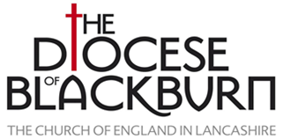

**Blackburn Diocesan Conference 2022**

**That you might have Faith. *Meeting Jesus in the Gospel of John.***

**7th to 10th November (Monday - Thursday)**

**The Hayes Conference Centre, Swanwick, Derbyshire DE55 1AU**

**BOOKING FORM**

**Lay Person:**

Name …………………………………………………………………….

Parish …………………………………………………………………

Email address: ……………………………………………………….

Contact phone number ……………………………………………



If prepared to share a room with whom would you like to share?

………………………………………………………………………..

Assistance needed………………………………….

Dietary issues ……………………………………….

NB If unable to stay for the full conference please give your arrival and departure time:

………………………………………………………………………………….

Emergency contact name & phone number:

…………………………………………………………………………………………….

(*Very important so we know who to contact should anything happen to you whilst at the conference*).

***Please return this form by email to Canon Jean Duerden, Conference Booking***

***Administrator at*** [conference@blackburn.anglican.org](mailto:conference@blackburn.anglican.org) ***or by post to: Bishop Philip North, Diocesan Offices, Clayton House, Walker Office Park, Blackburn BB1 2QE.***

Telephone queries to Jean Duerden 07976 528715 or Louise Hunter 01254 503087